NORTHEASTERN UNIVERSITY
COLLEGE OF ENGINEERING

PIEZOELECTRIC WALKWAY AT NORTHEASTERN UNIVERSITY
EMGT5220 – Engineering Project Management, Sec 05
Fall 2024
Instructor:
Bajracharya, Sharad
Team 2: Enviro-Mentalists
Point of Contact:
Sridhar, Bhavishya
Email: sridhar.bha@northeastern.edu
Mobile: +1(857) 423-5121
Team Members:
Kurmani, Gautham
Karuppusamy, Varshini
Naik, Nihar
Patil, Nishant
Shah, Ritul
Sridhar, Bhavishya
TABLE OF CONTENTS

LETTER OF TRANSMITTAL 4
EXECUTIVE SUMMARY 5
1. INTRODUCTION 6
1.1 Problem Statement 6
1.2 Solution 6
2. PURPOSE & OBJECTIVES 8
2.1 Purpose 8
2.2 Objective 8
3. TECHNICAL OVERVIEW 9
3.1 Piezoelectric Technology 9
3.2 Pavegen V3 Tiles Specifications 9
3.3 Site Selection 10
3.4 Electrical Connection 10
3.5 Energy Storage 11
3.6 Permitting and Approvals 11
3.7 Integration with high efficiency LED lights 12
3.8 Construction 12
4. IMPLEMENTATION PLAN 13
4.1 Planning Phase 13
4.2 Design Phase 14
4.3 Pre-Installation Phase 14
4.4 Site Preparation 15
4.5 Installation Phase 16
4.6 Electrical Connection and Wiring 17
4.7 Installation of Piezoelectric Tiles: 17
4.8 Testing Phase 18
4.9 Post-Installation Phase 19
4.10 WBS (WORK BREAKDOWN STRUCTURE) 19
4.11 SCHEDULE 20
4.12 RESPONSIBILITY CHART 20
4.13 RESOURCE ALLOCATION 21
4.14 STAKEHOLDERS 21
5. EXECUTION PLAN 24
5.1 Project Monitoring 24
5.2 Project Control 26
5.3 Project Auditing 27
5.4 Project Termination 28
6. RISK ASSESSMENT MANAGEMENT PLAN 29
6.1 Identification and Analysis of Risks: 29
6.2 Project Risk Register 30
6.3 Continuous Risk Assessment 32
7. FINANCIAL PLAN WITH BUDGET 33
8. TEAM CREDENTIALS AND CONTRIBUTION 34
9. References 35
10. APPENDICES 36

LETTER OF TRANSMITTAL
Date: 12/06/2024
Prof. Sharad Bajracharya
Northeastern Graduate School of Engineering
130 Snell Engineering
360 Huntington Avenue
Boston, MA 02135
Dear Prof. Sharad Bajracharya,
We are pleased to present you with the project proposal for the implementation of a piezoelectric walkway at Northeastern University. This project aims to transform kinetic energy from footsteps into a sustainable energy source for campus lighting, contributing to the university's environmental and sustainability goals.
The proposal outlines the installation of Pavegen tiles along the high-traffic walkway from Krentzman Quad to Snell Library. This system will generate renewable energy, store it in lithium-ion batteries, and power LED lights along the path. In addition to reducing electricity consumption, the project enhances campus visibility and serves as a tangible demonstration of innovative technology in action.
We are grateful for your guidance and feedback throughout this course. Which has been instrumental in refining our proposal and preparing us for future challenges as project managers. We hope you find our proposal compelling and impactful.
Sincerely,
Karuppusamy, Varshini
Kurmani, Gautham
Naik, Nihar
Patil, Nishant
Shah, Ritul
Sridhar, Bhavishya

EXECUTIVE SUMMARY
The Piezoelectric Walkway Project at Northeastern University is an innovative initiative aimed at integrating renewable energy technology into campus infrastructure. The project seeks to harness kinetic energy from foot traffic along the path from Krentzman Quad to Snell Library, converting it into electricity to power LED lighting. By leveraging piezoelectric tiles, this initiative aligns with the university's commitment to sustainability, enhances campus infrastructure, and reduces dependency on traditional energy sources.
The project is structured into key phases like planning, design and procurement, installation, and monitoring and evaluation. During the planning phase, feasibility studies are conducted to assess technical requirements and identify optimal site conditions. Consultations with stakeholders, including university administration, engineers, and sustainability experts, are integral in ensuring alignment with campus goals. In the design and procurement phase, durable Pavegen V3 tiles equipped with wireless sensors were selected for their efficiency in energy generation and ability to track foot traffic. The phase also involved procuring energy storage systems and ensuring compatibility with existing campus lighting. Installation encompasses site preparation, tile placement, electrical integration, and energy storage setup. Attention was also given to creating a system that would not disrupt pedestrian movement during installation, prioritizing user convenience and safety throughout the process. The final phase focuses on monitoring and evaluation, using tools like real-time data dashboards and performance reviews to measure energy output, lighting performance, and user satisfaction.
To maintain project momentum, Microsoft Project and Gantt charts are employed for progress tracking and timeline management. Weekly reviews and site inspections allow the team to address challenges promptly, ensuring adherence to budget and schedule. A well-defined set of key performance indicators (KPIs), including installation progress, energy generation, and milestone achievement, enables the team to measure success and make necessary adjustments. The total budget for the project is $1,388,836.69, covering materials, labor, and contingency.
The project is expected to reduce 2 tons of carbon emissions per year and save $ 60,000 annually in energy costs. In addition to cost savings, the system will reduce grid dependency during peak hours, contributing to campus energy resilience. Beyond measurable outputs, the project provides educational opportunities for students and faculty, fostering awareness of renewable energy and sustainable practices. The project is also designed with scalability in mind, offering a model for expanding similar technologies across the campus or other urban settings.
The Piezoelectric Walkway Project represents a step forward in sustainable innovation, transforming ordinary pedestrian movement into a renewable energy source. By enhancing campus infrastructure and promoting environmental responsibility, the project supports Northeastern University’s vision of a greener, more sustainable future. It sets a benchmark for other institutions, emphasizing the role of campuses in advancing global sustainability goals.

INTRODUCTION

Problem Statement
As the environment becomes crowded, the need for sustainable energy has increased drastically. The continual use of sustainable energy sources contributes to greenhouse gas emissions and leads to aggravating climatic changes. At Northeastern University, due to high foot traffic between Krentzman Quad and Snell Library, high kinetic energy is produced, which is being neglected and wasted. Instead of wasting this available energy, we can implement an innovative idea to utilize the kinetic energy for developing the infrastructure of the university. The kinetic energy generated by footsteps is often wasted [1]. This project aims to harness this energy using piezoelectric technology to address sustainability challenges and reduce reliance on non-renewable energy sources. Research shows that piezoelectric systems can effectively convert mechanical strain into electrical energy, making them suitable for urban infrastructure applications [2].

Solution
The project involves installing a piezoelectric walkway at Northeastern University, from Krentzman Quad to Snell Library. This location is chosen due to consistently high foot traffic from students, faculty and visitors. Krentzman Quadrangle serves as a central junction, connecting key areas on campus, while the Curry Student Center and the route towards Snell Library host numerous small campus events and are popular dining and study locations. With this high density of daily footfall, especially during peak hours and events, these locations maximize the potential to capture kinetic energy generated by pedestrian movement and convert it into electrical energy that powers the walkway lighting.

Production Methodology
The production methodology begins with a detailed site investigation to analyse pedestrian traffic and environmental conditions, estimating the kinetic energy that could be generated. Required permits from Northeastern University and the City of Boston will be obtained, following which the project team will start the full-fledged development.
Pavegen V3 tiles will be used as the piezoelectric material for their proven durability and energy conversion efficiency. When foot pressure is applied on these Pavegen tiles, they generate electricity by compressing internal piezoelectric materials, creating a charge through the internal shift of particles under stress. This energy will be collected and transmitted via copper wiring network to centralized lithium-ion batteries, which will store the generated energy. The batteries will be connected to an inverter to convert the stored DC power into AC. This system will be integrated with the existing lighting infrastructure, allowing generated energy to power high efficiency LED lights along the pathway.

Project Output
The primary output will be a fully operational piezoelectric walkway that generates energy to power the pedestrian lighting systems along the path from Krentzman Quad to the Snell Library. This will enhance sustainability by reducing reliance on the main electrical grid and demonstrate the feasibility of integrating renewable energy solutions into campus infrastructure. The success of the project will be measured by the energy generated and its ability to power the lighting system consistently, with data from the wireless sensors on the Pavegen tiles tracking foot traffic and energy output. Also, the metrics like energy savings and reduced carbon emissions will be used to evaluate the impact and scalability of the system for future expansion across the campus.

Innovative Edge
This project stands out due to its strategic placement in a high-traffic area, ensuring optimal energy harvesting. The use of piezoelectric technology is supported by studies highlighting its efficiency and potential for scalability in urban environments. By leveraging these technologies, the project aims to succeed where others have faced challenges, particularly in terms of practical implementation and sustainability impact.

PURPOSE & OBJECTIVES

Purpose
The purpose of our project is to address two critical challenges at Northeastern University: rising energy costs and increasing carbon emissions. By installing piezoelectric tiles along the walkway between Krentzman Quad and Snell Library, we aim to harness the kinetic energy from foot traffic and convert it into clean, renewable electricity to power pathway lighting. This initiative will help reduce the university’s reliance on conventional energy sources and lower operational expenses.
Additionally, the project supports Northeastern University’s Decarbonization and Resiliency Plan, contributing to its goal of achieving carbon neutrality. By converting wasted kinetic energy into usable power, we will minimize the campus’s carbon footprint while demonstrating the university’s commitment to sustainability and innovation.
Moreover, the project will lead to cost savings by reducing the amount of energy required to power pathway lights. These savings will grow over time, helping the university reduce its energy expenditures and further encourage the use of greener, more sustainable energy solutions [3].

Objective
- Energy Conversion: Our project aims to achieve a conversion efficiency of at least 75% for the kinetic energy generated by foot traffic into usable electrical energy. By utilizing piezoelectric technology and optimizing system design, this objective ensures minimal energy loss during the conversion process, maximizing the output from pedestrian activity.
- Lighting Effectiveness: The energy harvested from the piezoelectric tiles will be used to power at least 70% of the light poles along the walkway. This target will be met through the integration of energy-efficient LED lighting and a smart energy distribution system, ensuring that the generated energy is effectively utilized for campus lighting needs.
- System Durability: The piezoelectric tiles are designed to maintain operational functionality under the high pedestrian traffic of over 8,000 individuals daily. To achieve this, the tiles will be constructed from durable materials capable of withstanding continuous use and environmental factors, ensuring longevity and reliability.
- Cost Savings: A 20% reduction in electricity costs for lighting along the pathway is targeted within the first year of implementation. This will be achieved by offsetting conventional electricity usage with the renewable energy generated by the walkway, providing both financial and environmental benefits to the university.
- Energy Storage: To ensure continuous power supply even during low-traffic periods, an energy storage system will be incorporated into the design. This system will store excess energy generated during peak foot traffic times, enabling its use during off-peak hours and ensuring consistent pathway lighting.

These objectives collectively ensure that the project delivers a sustainable, cost-effective, and reliable energy solution while aligning with the university’s broader goals of sustainability and innovation.

TECHNICAL OVERVIEW

Piezoelectric Technology
Piezoelectricity is the property of certain materials such as Quartz, Rochelle Salt, Barium Titanate, Lead Zirconate Titanate (PZT), or Polyvinylidene Fluoride (PVDF) that generate an electric charge in response to the applied mechanical stress. This phenomenon arises from the internal structure of piezoelectric materials, such as certain ceramics and polymers, where charged particles shift their position when there is stress/compression on the material, creating an electric field. When some pressure is applied to these materials such as through footsteps on a walkway, the stress generates a small but usable electric energy. The ability to capture energy from mechanical movements that would otherwise be wasted makes piezoelectric technology a highly sustainable energy solution for urban applications. Integrating these piezoelectric systems into infrastructure like walkways can generate energy with reduced dependence on an electrical grid, providing a decentralized power source that aligns well with sustainability initiatives and renewable energy targets.

Pavegen V3 Tiles Specifications
The Pavegen V3 tile system is designed specifically for high-traffic areas where maximum energy capture and durability are essential. Each Pavegen tile is triangular, measuring approximately 50cm on each side, and has a composite structure that provides a balanced and stable surface. The triangular shape of the tiles is crucial as it ensures all footfall impact points are efficiently used, optimizing energy generation. At each corner of the Pavegen tile, electromagnetic generators are fixed. When pressure is applied to the tiles, the top surface of the tile depresses by 5mm to 10mm vertically, creating a downward force that initiates a rotation in these generators. This rotation generates an electrical current, and each footstep is sufficient to power an LED bulb for about 20 seconds. In other words, each footstep can generate 4 watts of power [4] [5].
The tiles are constructed from a composite material engineered for high wear resistance and are capable of withstanding substantial pedestrian footfall. The top surface is also treated with an anti-slip coating, making it safe for use in different weather conditions. The modular design of the Pavegen V3 tiles facilitates straightforward installation, allowing them to be easily deployed or expanded to other areas. Each tile can function independently within the network, ensuring continuous operation even if one segment requires maintenance. In addition to energy generation, the Pavegen V3 tiles are required with wireless API sensors that enable real-time data capture on pedestrian movement patterns. These sensors help gather data on foot traffic volume, frequency, and density across different times of the day, providing valuable insights into how the walkway is utilized. These sensors record each footstep, precisely counting daily pedestrian activity and footfall trends over time. This information helps to track peak traffic periods, offering insights into campus activity patterns.

Site Selection
The path from Krentzman Quadrangle to Snell Library was carefully chosen as the optimal location for the piezoelectric walkway due to its high foot traffic and central role in campus life at the University. This stretch of approximately 165 m is one of the busiest and most frequented areas on the campus, making it ideal for harvesting energy from pedestrian movement.
- Krentzman Quadrangle – A Central Attraction: Krentzman Quadrangle is one of the main attractions and gathering points on campus, often seen as the starting hub for students and visitors. It serves as a major junction, which leads to various key buildings, student centers, and classrooms. As an important landmark, Krentzman Quadrangle experiences consistent foot traffic throughout the day, providing a high baseline of pedestrian movement for energy generation. By placing the start of the walkway here, the project captures energy from one of the most trafficked entry points on campus.
- Pathway from Krentzman Quadrangle to Curry Student Center: The path from Krentzman Quadrangle to the Curry Student Center is always busy. Along this route, there is Dunkins, which is a popular stop for students and faculty in the mornings and afternoons. The Curry Student Center itself is a primary dining and social area, with multiple food stalls and seating spaces that attract huge students during mealtimes. This consistent flow of traffic from students heading to and from Curry makes it a prime area for energy capture.
- Curry Student Center to Snell Library – Curry Crossroads: This section of the path, known as Curry Crossroads, is a major intersection and event space on campus. Small events, student organization fairs, and various campus activities regularly take place here, drawing 1000+ students between 8 am to 10 pm daily and keeping this area busy at nearly all times of the day. The high student crowd at Curry Crossroads creates a unique opportunity for increased energy capture, as people stop, walk, and engage in activities within this space.

Electrical Connection
The electricity generated by each piezoelectric tile is transmitted through an efficient network of copper wiring. Each tile, when activated by the foot pressure, produces a small amount of charge that is immediately collected and routed to a storage system through individual copper wire connections. Copper is selected as the wiring material because of its high electrical conductivity, which minimizes resistance and ensures that the energy generated by the piezoelectric tiles is transmitted with minimal losses. Additionally, copper is highly durable and resistant to corrosion, which makes it suitable for underground installations where exposure to soil and moisture is continuous. The robustness of copper makes sure that the wiring network remains functional over time, even under different weather conditions.
Integrating the piezoelectric walkway system with the electrical grid presents several strategic advantages for the project. By connecting to the grid, excess energy generated during high foot traffic periods can be fed back into the grid, improving overall energy efficiency and potentially qualifying for energy credits through net metering. This ensures that even during times of low pedestrian activity, when the system’s energy generation might not meet lighting needs, the grid can provide backup power, maintaining consistent illumination. Moreover, grid integration allows for greater flexibility in managing energy resources across the campus and ensures that the system's energy generation can be optimized to meet demand, reducing the reliance on non-renewable energy sources.

Energy Storage
Once the electricity is generated by the piezoelectric tiles, it is directed to the energy storage system, which stores the energy until it is needed for campus use. This system uses lithium-ion batteries due to their high density, low self-discharge rate, and long cycle life, making them ideal for efficiently capturing energy generated by pedestrian traffic. Each lithium-ion battery module in the storage system has a capacity of around 25kWh, providing ample storage for electricity generated over time. With a nominal voltage of 48V, these batteries match the system's energy requirements and are designed to operate reliably across a broad temperature range, that is from -20ºC to 60ºC. This ensures functionality throughout seasonal weather fluctuations on campus. Approximately 4-5 Lithium-ion batteries will be required, each providing 10kWh storage. For optimal setup, these batteries could be strategically placed at central points along the walkway to minimize transmission losses and maintain balanced energy distribution. Two battery units could be located near Krentzman Quadrangle, another near Curry Student Center, and other two near Snell Library. Each of these locations would house weatherproof and secure battery enclosures, ensuring that energy generated is readily accessible for the LED lighting system and that the maintenance is also manageable.
To optimize battery management and longevity, the energy storage system is managed by a Battery Management System (BMS). The BMS monitors charging levels, balances cells, and regulates battery temperature to protect the battery array from overcharge, over-discharge, and overheating. By balancing the charge among cells, the BMS enhances overall storage efficiency, extending the life of each battery module and reducing the need for replacements. Additionally, a thermal management system with passive cooling elements like heat sinks and ventilation is integrated into the storage unit to release the heat generated during operation. This setup prevents thermal runaway, maintains safe operating conditions, and supports consistent performance.
Piezoelectric tiles generate Direct current (DC), which is not compatible with the campus lighting system that requires alternating current (AC). To convert DC to AC, the electrical setup includes inverters which are placed between the energy storage unit and the campus lighting infrastructure. These Inverters transform the steady DC output from batteries I to AC with precise frequency and voltage, enabling the stored energy to be seamlessly integrated into the existing lighting grid.

Permitting and Approvals
Before construction and installation of the walkway begins, the project requires necessary approvals from both Northeastern University and the City of Boston to ensure safety, accessibility, and environmental compliance. Within the University, facilities management, environmental health, and safety, and the office of sustainability review the project to ensure that it meets campus standards for infrastructure integration and environmental impact. Also, excavation and electrical permits from the Boston Public Works Department and the city's electrical inspection division are necessary, to confirm that all site modifications and electrical installations comply with municipal codes, including the National Electrical Code (NEC). Environmental permits ensure that the project aligns with Environmental Protection Agency (EPA) guidelines, protecting local ecosystems and integrating with the stormwater systems. The project must also meet Americans with Disabilities Act (ADA) standards o guarantee accessibility for all users. After the installation of the walkways, the inspections by campus and city safety officers finalize the approvals and confirm that the project fully adheres to all regulatory and safety requirements.

Integration with high efficiency LED lights
The energy generated from the Pavegen tiles will be integrated with the new high efficiency LED lights along the path from Krentzman Quadrangle to the Snell Library, replacing the existing walkway lights. These upgraded LED lights are specifically chosen because of their low energy requirements, making them compatible with the variable energy generated by foot traffic on the tiles. As the pedestrians’ step on the tiles, kinetic energy is converted into electrical energy and flows through a copper wiring network to a centralized junction box, then is stored in lithium-ion batteries. To make this generated energy suitable for the lighting system, inverters convert the stored DC into AC to power these LEDs. This setup allows the energy generated by foot traffic to supplement LED lighting, significantly reducing the walkways dependency on the main electrical grid and promote sustainability.
In different weather conditions, the system remains functional, as the Pavegen tiles are water resistant and are coated with anti-slip material for safety in wet/snowy conditions. However, extreme weather conditions, such as heavy snowfall, can lower the foot traffic, hence limiting energy generation. Also, low temperatures may reduce the efficiency of the battery storage system, temporarily impacting energy availability. Hence, to maintain consistent lighting, the LED light systems can use additional power from the main grid when the energy generated by foot traffic is insufficient.

Construction
The construction of the piezoelectric walkway requires precise excavation and site preparation. Excavation should reach a depth of 15 inches to accommodate the base layer, electrical conduits, and the tile itself, ensuring that the system is securely installed and meets safety standards. Excavators, backhoes, and trenching machines will be essential for efficiently preparing the site. Drainage solutions, such as a gravel layer or perforated piping, must be incorporated to prevent water accumulation that could affect the tiles and electrical components. The tiles must be aligned and securely placed, ensuring they generate optimal energy. Electrical wiring will be routed through trenches, requiring proper insulation and grounding for safety. Safety measures should be strictly followed, and the installation must comply with ADA accessibility standards.

IMPLEMENTATION PLAN
The implementation of the Piezoelectric walkway at Northeastern University will follow a structured Waterfall Methodology, progressing through clearly defined phases: Design, Procurement, Installation, Testing, and Handover. Each phase will be completed in sequence, ensuring a thorough and systematic approach to project execution. Close collaboration with Northeastern University officials, the sustainability team, financial managers, Civil engineers, Electrical engineers, and Supply chain managers will be essential throughout the process to maintain transparent communication, stay within the budget, and align with the project objectives.

Planning Phase

Initial Feasibility Check:
The locations for the installation of the piezoelectric sidewalks have already been selected with areas such as Krentzman Quadrangle, Curry Student Center, and the entrances of Snell Library with an approximate distance of 0.1 miles. Additionally, the technical feasibility of incorporating piezoelectric technology into the existing campus infrastructure will also be evaluated. This includes assessing the structural integrity of current walkways, determining the most efficient ways to channel the generated energy, and identifying any potential obstacles such as underground utilities or access points that could complicate the installation process. The project managers will work with Civil engineers, Sustainability experts, electrical engineers, and other stakeholders to coordinate the feasibility checks.

Assessment of foot traffic patterns:
A preliminary survey will be conducted to study the peak traffic hours, pedestrian movement patterns, and the other alternate routes that can be used during the construction period. The entire project team will work with the Northeastern University management to gather data on how many people use the walkways at different times of the day, ensuring that the traffic diversion measures are implemented effectively. Once the feasibility assessment and foot traffic pattern checks are completed, the results of this will provide critical data for decision-making, regarding the installation design and energy generation goals. By ensuring that all concerns are addressed upfront, this phase will lay the groundwork for a smooth, efficient installation process.

Compliance and Approvals:
The project requires securing the necessary permits and ensuring compliance with regulations from relevant departments within the city of Boston, such as the Boston Public Work Department, the Boston Planning & Development Agency, and other relevant authorities. Close coordination will be maintained with the university’s campus urban planning department, local authorities, and the sustainability committee. Risk assessments will be conducted to guarantee that the piezoelectric sidewalks meet all the safety, accessibility, and sustainability standards, including addressing potential trip hazards and risks of electrocution. Continuous monitoring and evaluations will be established to address any regulatory changes during the installation and operational phases. Regular updates and communication with the stakeholders will be maintained to ensure transparency and alignment with all the guidelines, needs, and requirements.

Design Phase
The design phase will mainly focus on collaborating with engineers to create efficient solutions that seamlessly integrate into existing pedestrian pathways, prioritizing durability and minimizing disruptions. Emphasis will be placed on creating durable designs that can withstand heavy foot traffic while maximizing energy capture. Following the successful feasibility checks and necessary approvals, the project is now ready to move directly to full-scale development and installation.
Pavegen tiles that are widely used for their ability to convert foot traffic into electrical energy will be used as piezoelectric tiles. The tiles are triangular, and each tile have a dimension of 50 cm on each side. The tiles will be installed along the pathway from Krentzman Quadrangle to the entrance of the Snell Library through the Curry Student Center, covering a total distance of approximately 165 meters. The layout will consist of four tiles placed in a single line, parallel to each other, extending along the length of the pathway. As the path from Quad to the Snell Library includes curves and turns, adjustments will be made to accommodate these variations. Tiles may be halted/adjusted at the bends, with the layout resuming its parallel configuration once the pathway straightens. The design team will also closely work with the installation crews to fine-tune placement plans and address any new challenges that arise. Continuous feedback loops and performance evaluations will be implemented throughout this phase to refine the designs and enhance the functionality as needed.
The design phase will also include the excavation plan required to install the piezoelectric tiles. The existing interlocks on the current walkway will be removed to prepare the place for excavation. The total excavation length will be approximately 165 meters, following the designated path from the Krentzman Quadrangle to the entrance of the Snell Library. The excavation breadth will accommodate the four tiles place, with additional space allocated on the sides to ensure proper alignment and stability. This extra space will also facilitate safe installation and maintenance access. The depth of the excavation will be approximately 15 inches to accommodate the tiles, wiring, and the base layer for the tiles.

Pre-Installation Phase

Traffic Diversion Planning:
The traffic diversion and site preparation phases are important, ensuring pedestrian safety, and preparing the site for smooth construction. These phases lay the groundwork for the successful tiles installation and ensure that the construction does not interfere with daily campus activities, while maintaining a safe environment for both pedestrians and construction workers. The area between Krentzman Quadrangle, Curry Student Center, and the Snell Library entrance is a very high-traffic area and hence careful planning is needed to manage pedestrian flow while the project is in progress.

Temporary Pathway Designation:
Once the development work starts, temporary pathways will be designated around the construction area. These pathways will be marked clearly and provide pedestrians with the necessary information to stay away from the construction site. Also, temporary detours will be placed to access key areas like Snell Library, Curry Student Center, and others during the construction period to provide directions to pedestrians regarding the alternative paths available to access the college facilities.

Barricade implementation:
To guide the pedestrians, safety barriers and detour signals will be placed at all entry points of the construction area. The barricades will be high-visibility yellow plastic barricades to separate the pedestrians from the active construction site. These barricades will be placed strategically at all intersections, entryways, and around the perimeter of the work zone. The signals will also include directions to the alternative routes and an approximate distance to the important landmarks of the campus. Signals such as Pathway Closed, Detour Ahead, and Follow Alternate Route will be placed at least 25 feet before reaching the worksite, to help pedestrians plan accordingly.

Communication with Campus:
To keep the University community informed about the project, digital communication channels like email, and the campus bulletin board will be used to provide necessary information like detours and traffic changes. Regular updates will be provided to Northeastern University administration and students & faculty as the project progresses to make sure that they are aware of any potential disruptions.

Site Preparation
Site preparation is a foundational step for ensuring that the construction area is ready for the installation of the piezoelectric tiles. In this phase, the designated area is cleared, conducting pre-construction assessments and setting up essential infrastructure for the installation work. The entry point for heavy machinery and other materials required for excavation and installation of tiles will be through Krentzman Quadrangle and the entrance of Snell library, and they will also serve as an exit point as well.

Clearing the Worksite and Excavation:
The first step in site preparation involves removing existing pavements/interlocks from the selected pathway. The Civil engineering team will begin by marking the site, which stretches from Krentzman Quadrangle through Curry Student Center and to the Snell Library entrance. Temporary Spray paints and construction flags will be used to mark the exact dimensions of the area to be worked out. Excavation will involve removing around 15 inches of the existing interlocks including the space to accommodate the piezoelectric tiles and underlying wiring. Heavy machinery such as excavators, backhoes, scrapers, and skid steer loaders will be used to clear the old interlocks. The debris of excavated interlocks will be transported off-site using dump trucks to prevent clutter around the construction area.

Base Layer and Conduit Installation:
Once the excavation process is complete a base layer will be installed to provide a stable foundation for the piezoelectric tiles. The base will consist of compact gravel and concrete to ensure proper drainage and stability. The gravel provides a flexible base that can handle 10 tons of pressure per tile from foot traffic, while the concrete layer adds additional strength to ensure long-term durability. Before laying the piezoelectric tiles, electrical conduits will be installed for wiring needed for energy transmission from the tiles to the energy storage units. These electric conduits will run below the tiles along the entire pathway and will be buried 12 inches deep to prevent any accidental damage from future construction work. The wirings that connect the piezoelectric tiles will be fed through these conduits which protect them from moisture, corrosion, and mechanical wear.

Drainage System Design:
Proper drainage is crucial for outdoor walkways to prevent water pooling and to maintain the functioning of the piezoelectric tiles. Drainage channels will be integrated into the sides of the pathway to allow rainwater to flow away from the tiles. These channels will be connected to the existing stormwater drainage system on campus to make sure that water does not accumulate on the surface, which can cause tile damage and slip hazards for pedestrians.

Implementation of Safety Measures During Site Preparation:
The entire area of the construction site will be fenced off with temporary construction fencing to prevent unauthorized access. This fencing will include warning signs and reflective tapes to alert people, especially during the nighttime when there is low light. Since the work involves excavation and the use of heavy machinery, dust control measures will be implemented. Water trucks will spray the worksite regularly to reduce the dust and ensure the health and safety of students and staff. All workers on site will be strictly required to wear proper personal protective equipment (PPE), including helmets, vests, gloves, and steel-toed boots to ensure their safety on the work site. Strict compliance with the Occupational Safety and Health Administration (OSHA) standards will be maintained throughout the project to make sure that there is a safe working environment. A clear emergency plan will be developed to ensure that emergency vehicles like fire trucks and ambulances can access all areas of the campus, even with the route diversions in place. Cooperation with Northeastern University management along with the Northeastern Public Safety Department (NUPD) will ensure that the plan is regularly reviewed and updated as needed.

Installation Phase
The installation of piezoelectric tiles is the core of this project which involves several steps to ensure that the tiles are properly embedded in the walkway, securely connected to the energy storage system, and capable of functioning optimally under regular pedestrian traffic. This phase is technically complex, requiring coordination between different teams such as Civil engineers, Electrical engineers, Supply Chain engineers, and project managers to seamlessly integrate the tiles into the Northeastern University campus infrastructure.

Vendor Management and Quality Control:
The piezoelectric material that will be used is Pavegen tiles. The Supply Chain team will coordinate with the chosen vendor to ensure that the materials are delivered on time. Upon delivery, the installation team will inspect the tiles for any defects such as cracks, chips, or faulty wiring. This is a very crucial step because if faulty tiles are installed, then it will cause a problem in power generation, hence this step will ensure that only functional tiles will be installed. Each tile will undergo pre-installation testing using portable equipment to ensure its piezoelectric components are fully operational.

Electrical Connection and Wiring
Once the tiles are laid, the next important step is establishing the tile's connection to the campus energy system. This involves careful wiring of the piezoelectric elements within each tile and making sure that the energy generated is transmitted to the storage systems.

Wiring and Electrical Connections of the Tiles:
The piezoelectric tiles are equipped with transducers that convert the mechanical stress into electrical energy. Each of these tiles consists of positive and negative electrodes connected to a central wiring system that channels the generated electric power. Copper wiring will be used for its superior conductivity, durability, as well as resistance to environmental conditions. The electrical engineers will connect the wires from each tile to an underground junction box, which will serve as a hub for the electrical connections. From the junction box, the wiring will continue through the conduits to a campus energy storage system in the form of batteries or through a direct connection to the grid. The batteries that we are using are Lithium-ion batteries and the specifications are given in the technical overview.

Connection to the Existing Lighting System:
The stored energy will be then routed to the existing sidewalk lighting system through the underground wiring, allowing the lights to be powered by the energy harvested from the foot traffic. The electrical engineers will ensure that the system is compatible with the existing grid, enabling seamless switching between the piezoelectric-generated power and the traditional electrical supply when necessary. Inverters will be used to convert the energy generated from the tiles into a form that can be used by the walkway lights.

Installation of Piezoelectric Tiles:
Once the electrical connections are done, the piezoelectric tiles are laid in sections along the designated pathway, starting from the Krentzman quadrangle and progressing toward the Curry Student Center and Snell Library entrance. Each piezoelectric tile will be placed carefully and aligned properly to ensure it fits seamlessly with the surrounding tiles and the existing interlocks. These tiles will be laid by civil engineers who specialize in infrastructure projects. These workers are responsible for physically placing the tiles and ensuring proper alignment, leveling, and secure installation. The dimensions of the tiles will be 50 cm x 50 cm which is one of the standard dimensions among Pavegen tiles. The layout will be designed in a modular fashion, allowing for future expansion if additional tiles are needed later. A tile-laying machine will be used to ensure that each tile is installed with precise alignment and proper leveling. The tiles must be laid completely flat to prevent any uneven surfaces that could cause trip hazards for pedestrians. Laser-guided leveling tools will be used to make sure that the entire walkway remains even. The Civil engineers work with the project managers to ensure that the deadlines are met, and the installation process is completed within the time.

Connection to the Existing Lighting System:
The stored energy will be then routed to the existing sidewalk lighting system through the underground wiring, allowing the lights to be powered by the energy harvested from the foot traffic. The electrical engineers will ensure that the system is compatible with the existing grid, enabling seamless switching between the piezoelectric-generated power and the traditional electrical supply when necessary. Inverters will be used to convert the energy generated from the tiles into a form that can be used by the walkway lights.

Battery Storage and Surge Protection:
If the generated electricity needs to be stored and used later, the lithium-ion batteries of 25kWh will be connected to the piezoelectric system. These Lithium-ion batteries will store the energy generated throughout the day and release it when needed, that is during the evening hours when the campus lighting systems are most in demand. The wiring system will also include surge protection devices to safeguard the devices from power fluctuations /short circuits. Additionally, a real-time monitoring system will be installed to track the energy output from the tiles, allowing the university to gather data on how much amount of energy is being harvested and how efficiently the entire system is working. The specifications of the batteries and the energy generation power of the tiles are explained in the Technical overview section.

Final Finishing and Stabilization of the Tiles:
Once the tiles are wired and tested, they must be securely fixed to the base layer to ensure that they are stable and durable enough to handle enough foot traffic. Each tile will be mechanically anchored to the base layer using stainless steel bolts. This will give the tiles a stiffness and the tiles do not shift or become loose over time due to pedestrian movement or weather conditions. The surface of the piezoelectric tiles will be treated with an anti-slip coating to ensure pedestrian safety, particularly during rainy and snowy conditions.

Testing Phase
Electrical engineers will test the tile's energy output by simulating the pedestrian traffic and measuring the amount of electric power generated per footstep. Pavegen tiles generate between 2 and 8 watts per footstep, with each footstep producing around 5 joules of kinetic energy, with a conversion efficiency of 5% to 10% [6]. The wiring connections to the battery will be tested to verify that the energy generated by the tiles is being correctly transmitted and stored. This will involve ensuring that the inverters are functioning properly and that there is no significant energy loss during the transmission. The piezoelectric tiles will also be tested under varied environmental conditions such as exposure to moisture, varying temperatures, and foot traffic simulations, to check whether the tiles can withstand the outdoor environment and maintain their efficiency over time.

Post-Installation Phase
Once the installation and the testing phases are complete, the system will be handed over to the University. Detailed documentation, including maintenance guidelines, technical specifications, and performance data will be provided to the university management team by the project manager. Additionally, the project manager will conduct training sessions to familiarize the college maintenance staff with the upkeep of the system, ensuring its smooth operation. After a final review with all the related stakeholders, the project manager will formally hand over the project to the university and address any immediate concerns post-installation. A monitoring dashboard will also be provided to the university to track the energy harvested by the tiles in real-time. This system will provide the data on a daily, weekly, and monthly basis, helping the university assess the overall effectiveness of the installation.

WBS (WORK BREAKDOWN STRUCTURE)
The Work Breakdown Structure (WBS) is a hierarchical framework that organizes all tasks that are essential for project completion. Dividing the entire project into phases like initiation, planning, execution, and closing, the WBS helps to assign roles, track progress, and allocate resources effectively. This structure ensures that every project element is addressed properly, enhancing clarity and communication within the team.
Project Initiation Phase
This phase involves defining the concept and goals for installing piezoelectric walkways. Key activities include project kick-off, defining project scope, framing a communication plan, and assessing the team's expertise to allocate responsibilities effectively This phase sets the foundation for the entire project by clarifying objectives and roles.
Project Planning Phase
During this phase, the team focuses on identifying material requirements, selecting vendors, and developing risk management strategies. Planning also includes evaluating the necessary approvals, such as city permits to ensure compliance. Additionally, this phase involves designing a timeline and assigning tasks, which helps in coordinating resources.
Project Execution Phase
The execution phase involves the installation and testing of the piezoelectric tiles, overseeing the construction processes, and integrating wiring and energy storage systems. Activities include excavation, equipment setup, technical testing, and alignment with safety protocols. This phase is important since it transforms the planning into actionable results through on-site work and system integration.
Project Closing Phase
The closing phase ensures project completion and a smooth operational transition. Key tasks include monitoring the performance of the piezoelectric system, troubleshooting any technical errors, and preparing a final report documenting all phases and outcomes.
For a detailed breakdown of all the tasks and activities involved in the project, refer to the Appendices A section which has the complete Work breakdown structure (WBS).

SCHEDULE
The schedule for our Piezoelectric Walkway Project at Northeastern University spans a total of 79 days, with each phase carefully planned to ensure efficient execution and timely completion. The first phase, initiation, will take 9 days and will focus on laying the foundation for the project. This will include defining the project's scope, assembling the project team, and ensuring that all key stakeholders are on board.
Following initiation, the planning phase is scheduled for 31 days. During this phase, we will finalize the design of the piezoelectric tiles, assess the feasibility of integrating the energy generation system with existing campus infrastructure, and prepare procurement strategies for materials and equipment. This period also includes risk management planning and addressing any potential challenges that may arise during execution.
The execution phase is the longest, spanning 33 days. This is when the majority of the work will be done, including the installation of the piezoelectric tiles along the pathway between Krentzman Quad and Snell Library, as well as the integration of the energy generation system with the lighting infrastructure. We will also perform testing and troubleshooting to ensure the system operates as expected.
Finally, the closure phase is allotted 4 days. During this time, we will conduct a final inspection to confirm that all project objectives have been met. Any adjustments or improvements will be made, and a thorough project review will be conducted to ensure the successful completion of the project. The final report will be compiled during the last 2 days, documenting the process, results, and any lessons learned.
For a more detailed schedule, please refer to Appendix B. With this detailed and structured timeline, we are confident that we can complete the piezoelectric walkway project on time, within budget, and contribute to a greener, more sustainable campus environment at Northeastern University.

RESPONSIBILITY CHART
A RACI Matrix is a project management tool used to clearly define roles and responsibilities for each task or deliverable in a project. The acronym RACI stands for Responsible Accountable Consulted and Informed which represent the four levels of involvement in each task. This matrix is particularly useful in complex projects with multiple stakeholders, as it helps avoid confusion, clarifies expectations, and ensures that each member understands their role in the project.
1. Responsible (R): These individuals are responsible for executing the task. They are the doers who perform the work to complete the task or deliverable.
2. Accountable (A): The accountable person is the owner of the task, ultimately answerable for its completion. They ensure that the task is done correctly and on time. For each task there should be only one accountable person to prevent ambiguity in decision making.
3. Consulted (C): They are typically engaged in a two-way communication process where they give feedback or advice to improve the quality or execution of a task.
4. Informed (I): They do not have responsibilities in the task but need to be kept informed as the task’s completion may affect their work or interests.
View Appendix C for the detailed Responsibility chart.

RESOURCE ALLOCATION
The resource allocation plan consists of expenses that includes labour, materials, construction, and other administrative costs that will be used for the project. To address any unplanned issues that may occur during the project, we have allocated a contingency cost of 7.41% to manage such scenarios [7]. View Appendix F for a more detailed view.

STAKEHOLDERS
The following list provides an overview of the key interested parties who are involved in the project. Each stakeholder plays a crucial role in ensuring the success of the project, from initial design through to implementation and campus integration. This collaborative approach ensures the project aligns with sustainability goals, optimizes energy use, and meets the needs of students, faculty and university administration.
Project Team
• Project Manager: Gautham Kurmani
Oversees the entire project, ensuring that the project stays on schedule and within the budget. Coordinates between different teams, manages resources, and addresses any issues that arise during the project lifecycle.
• Renewable Energy Development Manager: Ritul Shah
Focuses on integrating renewable energy solutions into the project. Makes sure that the piezoelectric walkway effectively generates energy, aligning with sustainability goals.
• Product Manager: Bhavishya Sridhar
Manages the development and implementation of piezoelectric tiles. Works closely with vendor and engineers to ensure product meets the specifications and performance standards
• Electrical Engineer: Nishant Patil
Designs and oversees the electrical systems of the walkway. Ensures proper installation and integration of the tiles with the energy storage and distribution systems.
• Civil Engineer: Varshini Karuppusamy
Responsible for the excavation plan, structural design and construction of the walkway. Ensures the walkway is safe, durable and compliant with building codes and regulations.
• Procurement Manager: Nihar Naik
Manges the sourcing and purchasing of materials and components that are needed for the project. Works with vendors to secure the best prices and ensures timely delivery of all materials.
Marketing Team
• Marketing Manager
• Financial Analyst
Vendors and Manufacturers
Below is the list of vendors and manufacturers supplying key components for the Piezoelectric Walkway: -
Piezoelectric Tiles:
• Pavegen Systems Ltd
Walkway Construction:
• AJ Masonry
• Galante Construction & Landscape Design
Lighting System:
• Northeast Electrical Distributors
• Boston Light Source
Batteries:
• A123 Systems Inc
• Northeast Battery
Engineering Services:
• TRG
• LTI Engineering
Customers
Primary Customer: Northeastern University
As the primary customer, Northeastern University is the main beneficiary of this project. This project will help Northeastern University generate energy, contributing to its sustainability goals and reducing costs. It also provides a unique feature that attracts students and faculty, showcasing the university’s dedication to cutting edge technology and environmental responsibility.

Secondary Customer: Students and Faculty of Northeastern University
The students and faculty are the direct users of this project. They will benefit from the enhanced infrastructure, which not only provides a functional walkway but also contributes to the university’s green initiatives. The energy generated by the walkway is used to power the lighting along the path of the walkway thereby reducing the overall carbon footprint.
Visitors, including parents and guests will experience the innovative walkway during their time on campus. This can leave a very positive impression and highlight University’s commitment to sustainability and technological advancement.

EXECUTION PLAN

Project Monitoring
To ensure the success of the piezoelectric walkway project at Northeastern University, a comprehensive project monitoring plan will be implemented. The project team will conduct weekly progress meetings to review updates, address challenges, and implement corrective actions as necessary to maintain alignment with the project timeline. These meetings will facilitate collaboration among team members and promote proactive problem-solving.
At the project’s start, well-defined objectives and key performance indicators (KPIs) will be established to assess performance across critical areas. These KPIs will include metrics such as installation progress, daily energy output, budget adherence, work quality, and milestone achievement. Regular evaluations of these metrics will enable prompt issue resolution and ensure alignment with project objectives. Site visits will play a pivotal role in the monitoring process. These inspections will allow for onsite assessments of progress, quality control, and early identification of potential issues. During each visit, the team will verify adherence to the project schedule, budget, and outlined specifications. Post-visit reports will be generated to document completed work, identified issues, corrective actions taken, and any necessary adjustments to the project timeline, budget, or scope.
Cost
- Break down all project expenses into categories such as labor, materials, equipment, and contingency to get a clear understanding of where funds are being allocated.
- Regularly monitor and review the budget to ensure spending stays within the limits and identify any discrepancies or overspending early on.
- Assess the project progress at key milestones to ensure that the results align with the investments made, and ensure that the resources are being used effectively
- Negotiate with the vendors to secure the best possible pricing for critical materials, such as the piezoelectric tiles and equipment, to reduce the costs without compromising quality.
- Keep all the relevant stakeholders updated on the financial status of the project, including any risks or deviations from the budget, and propose actionable solutions to mitigate them.
Staff
- The Project Manager will oversee all aspects of the project, ensuring that various teams are aligned, and the project stays on track. They will handle day-to-day coordination and address any issues that may arise.
- Engineers will be responsible for the technical elements: Mechanical Engineers will focus on the sidewalks' physical structure, Electrical Engineers will handle the energy conversion system, Civil Engineers will ensure the site is suitable for the installation, and the Renewable energy managers will oversee sustainability and ensure that the project meets environmental standards.
- The Product Manager will focus on evaluating the performance of the energy system, tracking energy generation, and identifying opportunities for system improvements based on the data analysis.
- The construction crew will be responsible for the physical installation of the sidewalk and energy systems. They will ensure that the construction is carried out according to the project plans and safety standards.
- The Quality Assurance Team will monitor the installation process to make sure that it meets the required quality and safety standards. They will ensure all components are functioning as expected and the project is being built to specification.
- The University Liaison will handle communication with the University administration, ensuring that all necessary permits and approvals are in place. They will also keep the project aligned with university policies and requirements.
Quality
- The materials selected for the project must efficiently convert foot traffic into usable electricity while ensuring that the batteries can store the energy for later use.
- Durability is crucial for the sidewalk, as it will need to withstand constant foot traffic and changing weather conditions. The materials must also minimize the need for ongoing maintenance while ensuring pedestrian safety and comfort.
- The project should be cost-effective, ensuring a balance between the upfront installation costs and the long-term energy savings generated by the system.
- The energy system should integrate seamlessly with the university’s existing energy grid, allowing for easy monitoring and optimization of performance.
- The design should not only be functional but should also blend well with the university’s campus aesthetic. It should be visually appealing while providing the necessary functionality.
Monitor and evaluate performance
- Continuously evaluate how the project is benefiting the University community by assessing improvements in lighting, energy generation, and overall user experience.
- If any issues are identified, such as low energy output or user dissatisfaction, the design or installation process should be adjusted. Adjustments might include optimizing energy generation, refining the design, or addressing concerns from the university community to improve performance and enhance user satisfaction.
Environmental Impact and Sustainability
- Monitor the environmental impact of the project by ensuring that the materials used are eco-friendly and that the design contributes positively to the environment.
- Assess how the project supports sustainability goals, such as reducing energy consumption, promoting renewable energy, and minimizing waste.
- Track the reduction in carbon footprint and energy savings compared to traditional lighting systems to showcase the project’s environmental benefits.

Project Control
Effective Project Control is vital for the successful execution of the Piezoelectric Sidewalk Installation project at Northeastern University. The project plan serves as a roadmap, defining the scope, objectives, and deliverables, along with the strategies needed to achieve them. The Project Manager will oversee all phases, ensuring alignment with project goals and managing resources effectively.
Regular monitoring of progress is critical to identify deviations from the plan. The project manager will track activities against the Schedule and resource allocation to detect any potential delays or risks. Early identification allows for corrective action, ensuring the project remains on schedule. For instance, if delays occur in the procurement of piezoelectric tiles, adjustments to subsequent tasks will be made to prevent further disruptions. Flexibility in project control is essential to handle changes in requirements or unforeseen challenges. For example, adjustments may be needed if there are delays in obtaining permits from the university or the City of Boston. The project manager will revise the schedule, reallocate resources, and update stakeholders to ensure the project remains viable.
Effective resource allocation will also be a priority. The project manager will ensure personnel, equipment, and materials are available and used efficiently. This includes coordinating the delivery of Pavegen tiles, scheduling installation crews, and managing energy storage systems to meet project timelines.
Budget Control
- Maintain detailed records of project expenditures, including the cost of piezoelectric tiles, batteries, electrical wiring, construction labor, and other equipment. Classify expenses such as materials, labor, and overhead for better tracking.
- Negotiate with suppliers for bulk discounts or extended payment terms to optimize cash flow. For example, establish favorable terms with Pavegen to reduce upfront costs and spread payments over time.
- Prepare financial reports for stakeholders, summarizing expenditures, variances, and corrective action. Justify any budget increases with data and projections to maintain transparency.
Change Control
- Establish a formal change request process, requiring detailed documentation of proposed changes, including their rationale, impact on scope, cost, schedule, and resource allocation.
- Convene a change control board comprising the project manager, key engineers, and stakeholder representatives to evaluate the impact of each request and make informed decisions.
- For the approved changes, update the project plan and schedule, ensuring that team members are informed and have access to revised documents. Communicate changes during team meetings and through project management platforms like Jira.
- Monitor the cumulative impact of changes to prevent scope creep and maintain project focus. Ensure that changes are necessary and aligned with the overall project objectives.
Risk Management
- Identify risks at each phase, such as delays in obtaining city permits, technical failures in the energy conversion system, or issues with integrating the system into the university’s power grid.
- Develop mitigation strategies for high-impact risks. For example, secure backup suppliers for critical materials and conduct contingency planning for weather-related construction delays.
- Perform regular risk assessment, updating the risk register with new risks as they arise and revising mitigation strategies accordingly. Assign risk ownership to team members responsible for monitoring and managing each risk.
- Conduct risk review meetings with stakeholders to discuss significant risks and their management. Maintain open communication channels for reporting emerging risks quickly.
Issue Management
- Set up a centralized issue log, detailing the nature, urgency, and impact of each issue. Include fields for tracking the issue status, assigned owner, and resolution timeline.
- Assign specific team members to investigate and resolve issues based on their expertise. For example, a technical issue with energy storage would be assigned to the electrical engineering team.
- Prioritize issues that could affect critical project milestones or compromise safety. Escalate high-priority issues to the senior management if additional resources or approvals are required for resolution.
- Implement a structured approach to issue resolution, using root cause analysis to identify underlying problems and develop effective solutions. Document all actions taken for future reference and lessons learned.

Project Auditing
The auditing process is critical in ensuring that the Piezoelectric Walkway at Northeastern University follows defined quality standards, schedules, and sustainability objectives. During this phase, a thorough evaluation of procurement processes ensures that all materials, including Pavegen tiles, lithium-ion batteries, and wiring meet all the technical specifications and are delivered on time without defects. Contracts with vendors, such as Pavegen Systems Ltd, are reviewed to confirm adherence to agreed terms. Installation audits verify the precise alignment and stability of the tiles, integration of electrical connections, and the effective functionality of drainage and anti-slip systems to ensure pedestrian safety.
The auditing process also involves leveraging real-time data from wireless sensors embedded in Pavegen Tiles to assess foot traffic and energy generation performance. This data validates whether the tiles meet the expected output range of 5 watts per step aligning with the sustainability goals. Simultaneously, compliance with regulatory requirements is examined, ensuring the project meets ADA accessibility standards and environmental guidelines as outlined in the permits from Northeastern University’s facilities and Boston’s Public Work Department.

Project Termination
The project termination phase is designed to transition the piezoelectric walkway into full operational status ensuring all deliverables meet stakeholder expectations and the goal of reducing campus energy reliance on non-renewable sources. This phase begins with a thorough review of project outcomes, including energy generation metrics and operational consistency of the lighting system powered by the walkway. Final inspections confirm the proper functioning of all components, from the tiles to electrical connections and energy storage systems.
- Develop a Project Closure Plan: Review project outcomes, ensuring energy generation metrics and lighting system functionality align with objectives. Conduct final inspections to confirm all components, including tiles, electrical connections, and storage systems are operational.
- Approval from Stakeholders: Organize a formal handover meeting with university officials and sustainability teams to present the systems operation guide, energy metrics, and maintenance schedules. Secure stakeholders’ approval for project closure.
- Training and Monitoring Setup: Train maintenance staff on managing lithium-ion batteries, piezoelectric tiles, and inverters. Provide a real-time monitoring dashboard for tracking energy performance and system health.
- Conduct a Final Project Review: Gather feedback from students, faculty, and administrators to evaluate user experience. Analyze energy savings and carbon footprint reduction to assess project success.
- Maintain Project Documentation: Prepare a final report with technical data, financial summaries, and stakeholder input. Achieve documentation for scalability and as a reference for future

RISK ASSESSMENT MANAGEMENT PLAN

Identification and Analysis of Risks:
For a project to be successful, a risk assessment management plan is very essential. The first step in risk management is to compile a list of potential risks that could affect the outcome of the project. These risks can be classified into various categories such as Operational risk, Security risk, Workforce risk, financial risk, Construction risk, and so on. The risks are ranked according to their effects and probability of occurrence. These risks are given a score using a risk assessment matrix. Then, investigations are made to determine the depth of the potential effects, root cause, and effective countermeasures. The risk response plan is made for each identified risk. To ensure success, it is essential to continuously monitor and effectively manage risks throughout the entire course of the project.
Operational Risks
- Since the power generation in a piezoelectric tile depends on the mechanical stress applied, it may not always be consistent.
- Periodic maintenance is required for the efficient functioning of the system. This periodic maintenance could cause disturbance to the people using the walkway on a daily basis.
- The mechanical strain that generates electricity varies based on the frequency and intensity of foot traffic, which in turn creates variability of energy output.
- The wireless API sensor is responsible for collecting and transmitting data related to the generation of energy. Failure of this sensor may lead to data breaches and exposure of user data.
- Interference or damage from external sources could affect the functioning of the walkway light
Security Risks
- Damage or theft of the sensor, batteries, or piezoelectric tiles can significantly impact inventory levels.
- Improper installation of the piezoelectric tile could cause injury risk to pedestrians.
- Insecure storage of foot traffic data or energy usage can be misused by hackers.
Maintenance Risks
- The piezoelectric walkway relies on the piezoelectric tiles, sensors, lighting components, and energy storage system. Improper maintenance of these components could affect the functionality of the walkway.
- The continuous power supply to the walkway’s lights depends on the energy-storing batteries. Degradation of these batteries over time could affect the working of the lights.
- The efficiency of the sensors or the energy-storing batteries could decrease over time.
Financial Risks
- Additional costs, unexpected technical requirements, and liability for accidents could increase the expense cost.
- Due to permitting delays, the cost of labor may increase.
- Insufficient funding from the university or a third-party sponsor may affect the project.
Construction Risks
- Shortage of raw materials or equipment will disturb the timeline of the project and affect the completion of the project.
- Supplier delays and shipping delays could cause schedule overruns which will impact the project timelines and production schedule. It may also lead to dissatisfaction among the clients.
- The damage to the piezoelectric tile will affect the functioning and efficiency of the system.
Workforce Risks
- Accidents or injuries that happen in the work area or to the workers of the project will delay the project and increase the cost of the project.
- The shortage of skilled workers or difficulty in hiring qualified workers will affect the project’s timeline and delay the completion of the project.
Legal and Compliance Risks
- Violating the building codes could result in fines or a redesign of the plan.
- When the electrical safety standards for the project are not followed properly, it will lead to legal challenges which in turn will delay the project.
- If the permit required for the project is delayed or denied, the timeline of the project will be affected and sometimes, it may lead to the halt of the project entirely.

Project Risk Register
The risk register is a risk management tool that is used to identify the potential risks that could affect the execution of a project plan. The risk register is mostly used during the execution phase, but it should be created during the planning phase of the project. It helps the project managers list the possible risks, their level of priority, mitigation strategies, and the required action to solve the risk.

Risk Description |  |  | Likelihood | Impact | Rank (Likelihood* Impact) | Action Plan
Damage of tiles |  |  | Medium | High | 6 | Applying an extra protective coating, to reduce the tear and wear of the tiles and increase the lifetime of the tiles.
Uneven foot traffic |  |  | Low | Medium | 2 | Conducting proper surveys to ensure that high high-traffic area has been selected for the installation of the pathway.
Failure of wireless sensor |  |  | Medium | High | 6 | Using high-quality sensors and installing an error-checking mechanism can prevent the failure of the sensor.
Damage by an external source |  |  | Low | Medium | 2 | Installation of vandal-resistant fixtures made from robust materials can be used to protect the system from external damage.
Theft of component |  |  | Low | Low | 1 | Securing the area and notifying the campus security can prevent further theft.
Insecure storage of data |  |  | Medium | Medium | 4 | Proper encryption of energy usage data and foot traffic data using secure protocols like Transport Layer Security will secure the data from potential hackers.
Degradation of energy storage |  |  | Low | High | 3 | Usage of high-quality lithium-ion batteries and installing them in a well-ventilated place could prevent the degradation of the batteries.
Decrease of efficiency |  |  | Low | High | 3 | Examining the components for high durability, wear resistance, and reliability will maintain the efficiency of the components over time.
Additional, unexpected cost |  |  | Low | High | 3 | Performing a detailed cost analysis and creating a detailed budget list with the contingency funds will help to cover the additional costs.
Permitting delays |  |  | Low | High | 3 | Start preparing the documents for the permit process well in advance, so that there will be no delay in the approval of the permit.
Damaged equipment |  |  | Low | Medium | 2 | Regular inspection and monitoring of the equipment could reduce the damage.
 | Inadequate training for staff | Medium |  | High | 6 | To guarantee staff proficiency with the systems, implement comprehensive training programs and conduct  regular skill evaluations.
 | Over-reliance on a single vendor | Medium |  | High | 6 | Create several supplier partnerships to reduce the chance of vendor problems or failures.
 | Unexpected environmental regulations | Low |  | High | 3 | Remain informed about regional environmental regulations and get advice from legal professionals to guarantee adherence and minimize project delays.
 | Equipment issues | Medium |  | High | 6 | During the procurement process, conduct thorough compatibility testing and consult technical specialists to determine whether component integration is  feasible.
Degradation of energy storage.  Decrease of efficiency.  Additional cost.  Permitting delay.  Unexpected Environmental regulations. | Damage of tiles.  Failure of wireless sensor.  Violating codes.  Equipment issues.  Relying on a single vendor.  Inadequate training.
Uneven foot traffic.  Damage by external sources.  Insufficient funding.  Damaged equipment.  Delay in service. | Insecure storage of data.  Delay for a permit.  Complex design. | Unexpected accidents.
Theft of components.  Shortage of workers. | Shortage of equipment.  Supply delay.  Complaints from walkway users. | Dispute in electrical safety.
Probability
Impact
Figure 6.2: Risk Matrix

Continuous Risk Assessment
During the Piezoelectric Walkway project at Northeastern University, ongoing risk monitoring is essential for spotting and resolving possible issues. Proactively reducing risks that could affect the budget, schedule, or functionality is the aim. The team supports Northeastern University’s sustainability goals by ensuring timely modifications and alignments with the project’s objectives through frequent assessments and stakeholder involvement.

FINANCIAL PLAN WITH BUDGET
Our project’s financial plan focuses on minimizing upfront costs while maximizing long-term savings. The initial investment will cover the purchase and installation of the piezoelectric tiles and the necessary infrastructure for energy storage and distribution. We aim to secure funding through university grants, sustainability initiatives, and potential partnerships with green energy organizations.
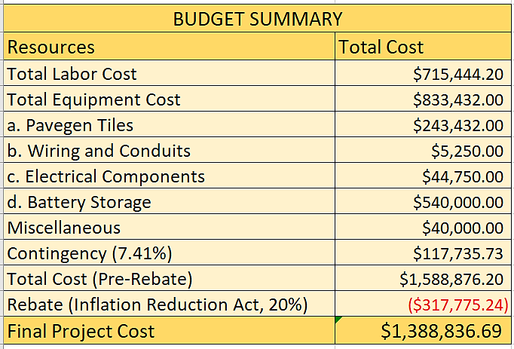
In the long term, the project will reduce electricity costs by generating clean energy to power pathway lighting. The savings on energy bills are expected to offset the initial investment within a few years. Over time, the system will continue to provide cost savings, further improving the university’s financial sustainability while supporting its commitment to green energy. To ensure the project stays on track and within budget, we’ve developed a detailed financial plan, allocating resources for labor, equipment, and contingencies. The Budget Summary of which is shown below. The complete justification for the budget can be referred to in Appendix D.

Table 7.1: Budget Summary

Figure 7.1: Project budget summary chart

TEAM CREDENTIALS AND CONTRIBUTION
Team Member | Contribution
Kurmani, Gautham | Focused on the implementation plan and developed the Work Breakdown Structure, RACI matrix, Letter of transmittal, executive Summary, Project Monitoring and Control, and technical overview of the project. Also developed the handouts
Karuppusamy, Varshini | Contributed by developing the project’s problem statement, solution plan, and resource allocation. Also worked on the Risk management plan
Naik, Nihar | Worked on the project’s problem statement and solution plan and created the financial plan with budget. Also, worked on risk management and risk register
Patil, Nishant | Worked on the stakeholder management aspect of the project, identifying and analyzing key stakeholders involved. Also, worked on Project Monitoring and Control
Shah, Ritul | Contributed to the implementation plan and developed the responsibility chart. Also researched piezoelectric tiles, reviewing relevant articles and papers. Worked on the Project Auditing and termination
Sridhar, Bhavishya | Contributed to defining the project’s purpose, scope, and objectives. Played a key role in developing the project schedule, managing citations and references. Consolidated information provided by teammates to create a comprehensive and well-structured project report. Actively facilitated team communication and worked on creating the PPT presentation.

References
[1] | E. M. Nia, “A review of walking energy harvesting using piezoelectric,” IOP Conf. Series: Materials Science and Engineering, 2017.
[2] | J. R. Andrade, “Piezoelectric Energy Harvesting: A Comprehensive Review and Applications,” 2022.
[3] | D. C. S. D. A. N. M. F. ,. S. I. L. S. D. X. H. Lubinda F. Walubita, “Prospective of Societal and Environmental Benefits oF Piezoelectric Technology in Road Energy Harvesting,” MDPI, 2018.
[4] | S. McClary, “Tech: Pavegen – the technology behind the tile,” 2017. [Online]. Available: https://www.egi.co.uk/news/pavegens-the-technology-behind-the-tile/.
[5] | L. Skrabania, “Reset,” 28 02 2018. [Online]. Available: https://en.reset.org/pavegen-generate-clean-electricity-while-taking-stroll-02272018/.
[6] | “The Switch,” 08 04 2022. [Online]. Available: https://theswitch.co.uk/energy/guides/technology/energy-harvesting-tiles.
[7] | “U.S. Bureau of Labor statistics,” 03 04 2024. [Online]. Available: https://www.bls.gov/oes/current/oes_71650.htm.

APPENDICES
Appendix A: Work Breakdown Structure
ID | TASK
1 | PIEZOELECTRIC WALKWAYS AT NORTEASTERN UNIVERSITY
2 | 1.0 Project Initiation Phase
3 | 1.1 Project Kick-Off Meeting
4 | 1.1.1 Define project scope, objectives, and deliverables
5 | 1.1.2 Develop a communication plan with stakeholder contact details
6 | 1.1.3 Form a project team with defined roles
7 | 1.2 Stakeholder Engagement
8 | 1.2.1 Identify internal stakeholders (University facilities, engineering, sustainability)
9 | 1.2.2 Identify external stakeholders (City regulatory bodies)
10 | 1.2.3 Develop a stakeholder engagement plan
11 | 1.3 Project Charter Development
12 | 1.3.1 Draft initial project charter with mission and benefits
13 | 1.3.2 Review and obtain necessary approvals from key stakeholders
14 | 2.0 Project Planning Phase
15 | 2.1 Initial Feasibility Study
16 | 2.1.1 Conduct site assessment for compatibility and utilities
17 | 2.1.1.1 Evaluate layout compatibility and wiring feasibility
18 | 2.1.1.2 Assess structural compatibility
19 | 2.1.2 Perform foot traffic analysis
20 | 2.1.2.1 Identify peak traffic hours and movement patterns
21 | 2.1.2.2 Collect data for energy output estimators
22 | 2.1.3 Prepare feasibility reports and obtain approvals
23 | 2.2 Regulatory Compliance and Permits
24 | 2.2.1 Identify required city and university permits
25 | 2.2.2 Obtain necessary permits for construction
27 | 2.2.3 Compliance with city regulations to meet building standards
28 | 2.2.4 Create a risk management and compliance checklist
29 | 2.3 Design and Engineering
30 | 2.3.1 Design of layouts for walkway installation
31 | 2.3.1.1 Define tile placement for energy capture
32 | 2.3.1.2 Plan pedestrian flow and alignment with existing campus design
33 | 2.3.2 Design of the wiring and drainage system
34 | 2.3.2.1 Design of wirings for energy transfer
35 | 2.3.2.2 Implement drainage system for weather resilience
36 | 2.3.2.3 Design of the energy storage system
37 | 2.3.3 Excavation Plan Design
38 | 2.3.3.1 Outline the area for excavation
39 | 2.3.3.2 Outline tools and equipment needed for excavation
40 | 2.3.3.3 Prepare a plan for temporary site adjustments
41 | 2.3.4 Material Selection for the Piezoelectric Tiles
43 | 2.3.4.1 Choose durable piezoelectric material resistant to weather conditions
44 | 2.3.4.2 Define the specifications of the selected tile
45 | 2.3.4.3 Estimate power generation capacity of the tiles
46 | 2.4 Procurement Planning
47 | 2.4.1 Vendor identification and selection
48 | 2.4.1.1 Identify vendors for tiles, wiring, and materials
49 | 2.4.1.2 Draft contracts specifying technical requirements
50 | 2.4.1.3 Create purchase order requests
51 | 2.4.2 Order of materials necessary for installation
52 | 2.4.2.1 Schedule of material and equipment delivery according to the phase
53 | 2.4.2.2 Secure on-site storage on the campus
54 | 2.4.3 Inspection of the incoming materials
55 | 2.4.3.1 Develop inspection criteria for incoming materials
56 | 2.4.3.2 Establish a checklist for on-site material checks
57 | 2.4.3.3 Clearing of the damaged or non-compliant materials
58 | 2.5 Workforce and Resource Planning
59 | 2.5.1 Identify the roles and responsibilities needed for the project
60 | 2.5.2 Determine the number of personnel needed for each role
61 | 2.5.3 Estimate the hours required for each role
63 | 2.5.4 Allocate budget for workforce
64 | 2.6 Risk Assessment and Mitigation Planning
65 | 2.6.1 Identify design and installation risks
66 | 2.6.2 Create emergency protocols for high-risk scenarios
67 | 2.6.3 Develop strategies to mitigate identified risks
68 | 3.0 Project Execution Phase
69 | 3.1 Site Preparation for Construction
70 | 3.1.1 Site Cleaning
71 | 3.1.1.1 Removal of the existing interlocks through jackhammers
72 | 3.1.1.2 Transport of the walkway debris for disposal
73 | 3.1.1.3 Mark areas for the walkway excavation after interlock removal
74 | 3.1.2 Traffic Diversion Plan
75 | 3.1.2.1 Install barricades and signage around the construction site
76 | 3.1.2.2 Setup temporary pathways and detours
77 | 3.2 Excavation and Base Layer Installation
78 | 3.2.1 Use machinery for excavation and leveling
79 | 3.2.1.1 Sourcing of the tools and machinery for excavation
80 | 3.2.1.2 Conduct precise excavation using heavy machinery
81 | 3.2.1.3 Transport of the excavation debris for disposal
82 | 3.2.1.4 Leveling of the excavated area
83 | 3.2.2 Base layer and drainage setup
84 | 3.2.2.1 Lay gravel and concrete for stability
85 | 3.2.2.2 Compact base layer in preparation for tiles
86 | 3.2.2.3 Setup drainage systems to manage water flow
87 | 3.2.2.4 Lay conduits for wiring and power transfer
88 | 3.3 Installation and anchoring of the tiles
89 | 3.3.1 Installation of tiles
90 | 3.3.1.1 Align tiles according to the layout design with even spacing
91 | 3.3.1.2 Level each tile to ensure smooth, flush surface
92 | 3.3.1.3 Check tile connections to adjacent tiles for structural integrity
93 | 3.3.2 Securing and Anchoring of tiles
94 | 3.3.2.1 Use appropriate anchors to firmly secure each tile in place
95 | 3.3.2.2 Apply anti-slip coatings to tile surface for pedestrian safety
96 | 3.3.2.3 Prepare tile connectors for integration with the electrical wiring system
97 | 3.4 Electrical Wiring and System Integration
98 | 3.4.1 Connect tiles to the junction boxes for energy transfer
99 | 3.4.2 Install battery storage and inverters for energy management
100 | 3.4.3 Monitoring and control system
101 | 3.4.4 Connection to the existing walkway light poles
102 | 3.4.5 Test wiring and ensure surge protection compatibility
103 | 3.5 Quality Control and Inspection
104 | 3.5.1 Inspect tile placement, wiring, and base integrity
105 | 3.5.2 Verify compliance with established safety standards
106 | 3.5.3 Conduct load testing for durability under pedestrian traffic
107 | 3.6 Testing and Calibration
108 | 3.6.1 Simulate energy output for expected performance
109 | 3.6.2 Test power storage efficiency and system resilience
110 | 3.6.3 Verify lighting system integration and functionality
111 | 3.7 Site Restoration and Finishing Touches
112 | 3.7.1 Restore landscape to original condition post-installation
113 | 3.7.2 Replace any removed markers and install new signage
114 | 3.7.3 Perform final cleaning and remove all debris
115 | 4.0 Project Closure Phase
116 | 4.1 Review the deliverables of the project
117 | 4.2 Audit Procurement
118 | 4.2.1 Contract closure with vendors and suppliers
119 | 4.2.2 Archive project resources and documentation
120 | 4.3 Setup Operations and Maintenance Team
121 | 4.4 Provide Final Project Report

Appendix B: Project Schedule
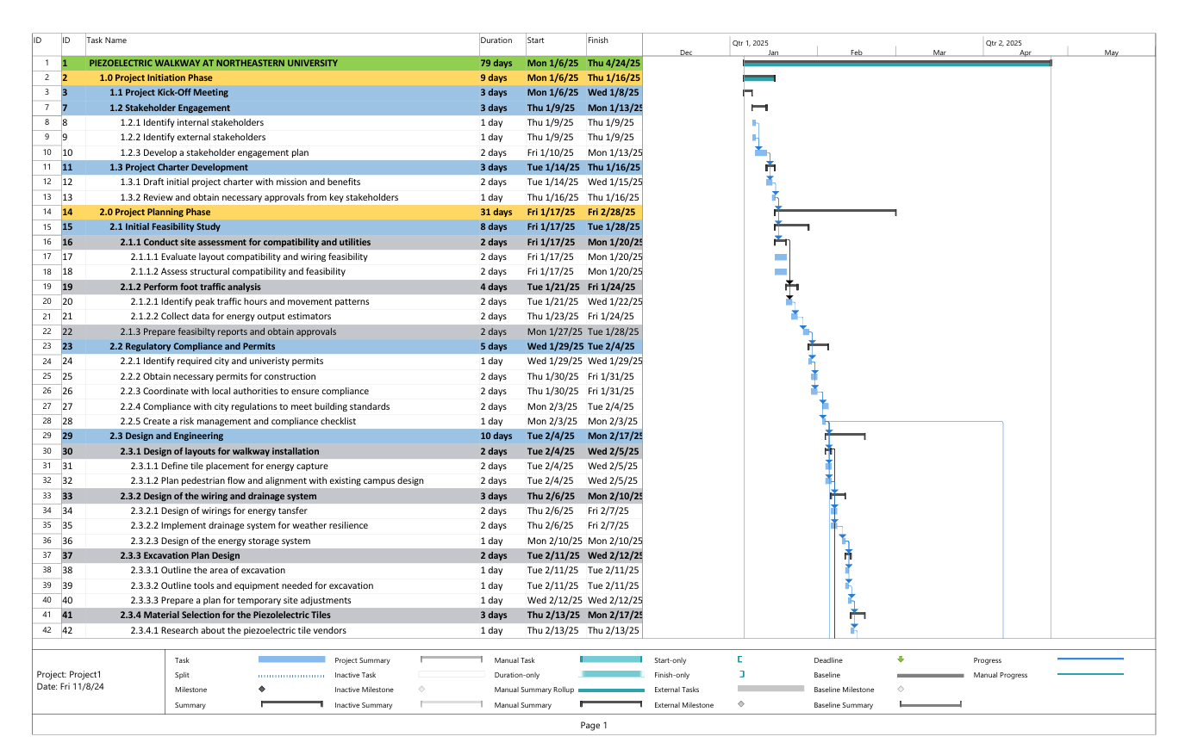
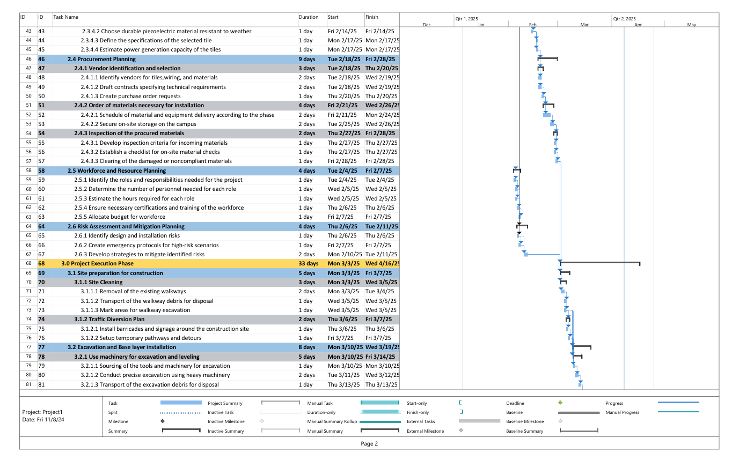
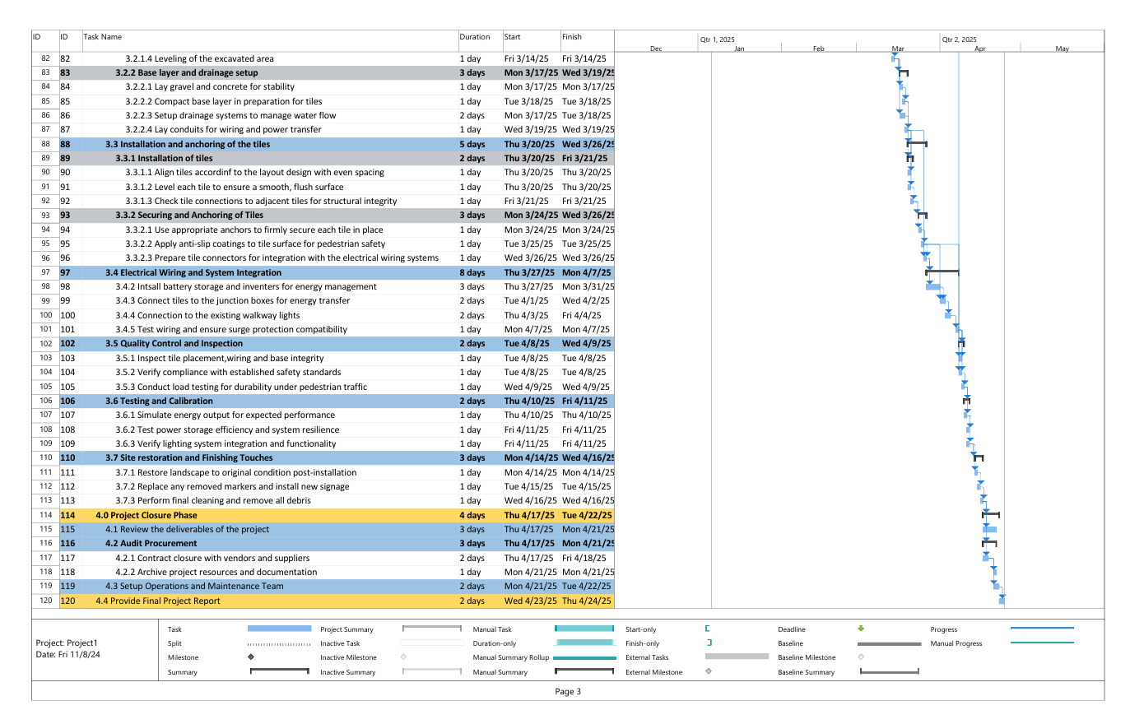
Appendix C: RACI Matrix
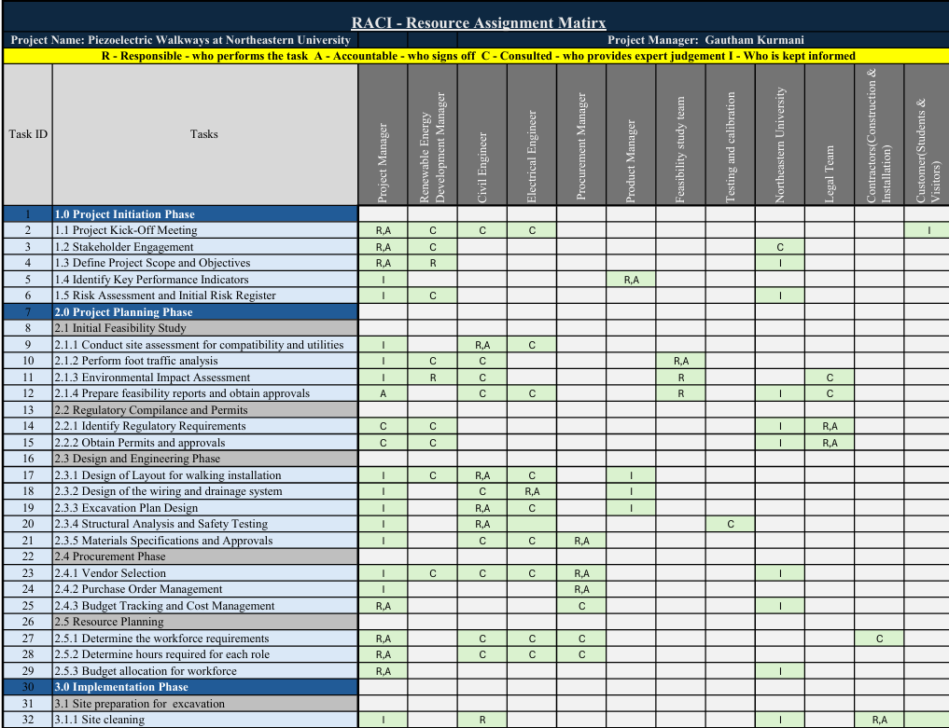


Appendix D: Financial Plan with Budget
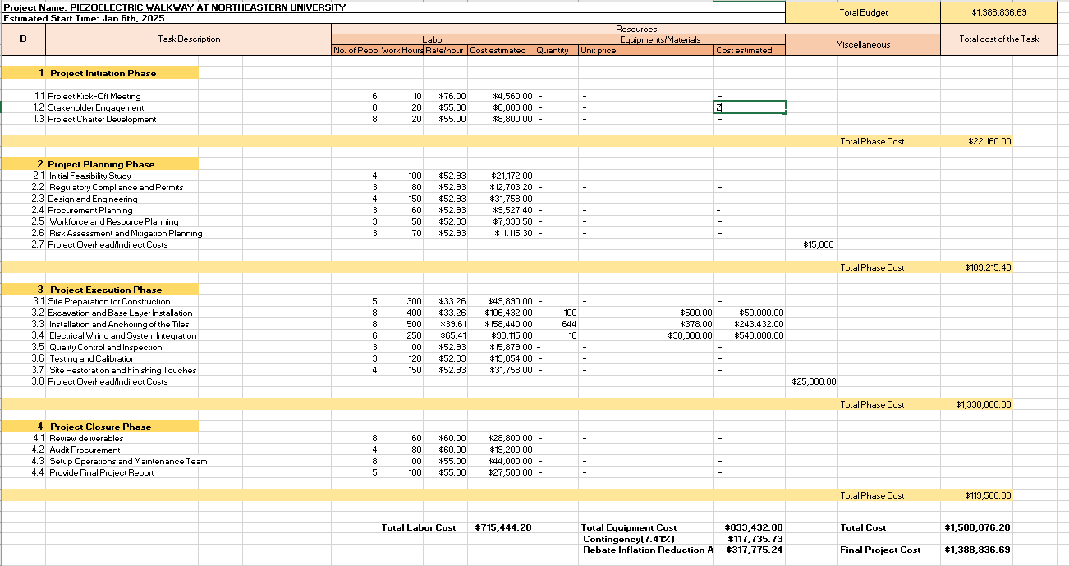

Appendix E: Resource Allocation
